# PROJECT ON STUDENT DATA USING SQL AND POWER BI:

**The STUDENT DATA is given below**

**Student Data Analysis Project**

Welcome to the Student Data Analysis Project! This project demonstrates how raw CSV data can be transformed into meaningful insights using SQL and Power BI.

**Project Overview**

This repository contains:

* A CSV file with student marks data
* SQL scripts to analyze the dataset (using aggregate functions, filters, grouping, and more)
* An interactive Power BI dashboard to visualize trends, distributions, and performance metrics

The goal is to showcase how data can be cleaned, queried, and visualized to drive academic or institutional insights.

**Dataset**

The dataset includes:

* Student details (Roll No, Name, Section, Course)
* Subject-wise marks
* Performance indicators

**SQL Analysis Highlights**

Key insights derived using SQL include:

* Count of students scoring above 90 in each subject
* Section and course-wise performance grouping
* Usage of WHERE, GROUP BY, and simple clauses
* Data aggregation and filtering examples

You can find all SQL queries in the code.sql folder.

**Power BI Dashboard**

Explore interactive visuals such as:

* Course & Section-wise high-scorer distribution
* Subject-wise average marks
* Heat maps and bar charts for quick comparison

|  |  |  |  |  |  |
| --- | --- | --- | --- | --- | --- |
| **Name** | **Roll No** | **Section** | **Course** | **Marks** | **Age** |
| Devin Holloway | CS2025001 | C | Biology | 60 | 19 |
| Karen Mckinney | CS2025002 | A | Biology | 61 | 20 |
| Angela Clark | CS2025003 | B | Chemistry | 45 | 20 |
| Joshua Bates | CS2025004 | C | Computer Science | 66 | 20 |
| Robert Jimenez | CS2025005 | B | Chemistry | 39 | 18 |
| Keith Gonzalez | CS2025006 | A | Biology | 55 | 20 |
| Ronald Davis | CS2025007 | B | Biology | 77 | 21 |
| Christopher Mcgrath | CS2025008 | A | Computer Science | 55 | 18 |
| Michelle Tucker | CS2025009 | A | Chemistry | 71 | 21 |
| Steven Hendrix | CS2025010 | B | Math | 37 | 19 |
| John Yates | CS2025011 | B | Math | 76 | 21 |
| Laura Henderson | CS2025012 | A | Math | 48 | 19 |
| Heather Wilson | CS2025013 | C | Math | 65 | 21 |
| Christina Austin | CS2025014 | C | Chemistry | 40 | 21 |
| Allen Smith | CS2025015 | C | Computer Science | 90 | 19 |
| David Newman | CS2025016 | B | Math | 67 | 19 |
| Dominic Lucero | CS2025017 | A | Computer Science | 97 | 18 |
| Susan Butler | CS2025018 | A | Physics | 37 | 18 |
| Heather Hendricks | CS2025019 | A | Biology | 35 | 18 |
| William Johnson | CS2025020 | C | Biology | 70 | 19 |
| Tiffany Lopez | CS2025021 | B | Math | 43 | 19 |
| Nicole Gonzalez | CS2025022 | B | Math | 97 | 22 |
| Robert Sanchez | CS2025023 | C | Chemistry | 43 | 21 |
| Antonio Lawrence | CS2025024 | C | Chemistry | 48 | 21 |
| Daniel Leach | CS2025025 | B | Math | 43 | 20 |
| Michael Murray | CS2025026 | A | Computer Science | 51 | 20 |
| Brittany White | CS2025027 | C | Physics | 67 | 20 |
| Wendy Wilson | CS2025028 | B | Math | 67 | 21 |
| Joseph Jackson | CS2025029 | A | Computer Science | 42 | 20 |
| Joyce Taylor | CS2025030 | A | Chemistry | 35 | 18 |
| Kim Myers | CS2025031 | C | Biology | 94 | 20 |
| Kim Kaiser | CS2025032 | A | Chemistry | 37 | 22 |
| Nicholas Chavez | CS2025033 | A | Physics | 84 | 22 |
| Dennis Shaw | CS2025034 | A | Chemistry | 84 | 22 |
| Sarah Henry | CS2025035 | C | Math | 85 | 18 |
| Christian Daniel | CS2025036 | B | Chemistry | 79 | 19 |
| Jesse Garrison | CS2025037 | A | Physics | 86 | 18 |
| Alyssa Bolton DDS | CS2025038 | C | Physics | 91 | 21 |
| Keith Schwartz | CS2025039 | C | Math | 35 | 20 |
| William Simmons | CS2025040 | C | Chemistry | 81 | 20 |
| Ian Jackson | CS2025041 | A | Biology | 48 | 20 |
| Jason Dillon | CS2025042 | B | Chemistry | 61 | 19 |
| Erica Brown | CS2025043 | A | Biology | 87 | 21 |
| Sara Wilson | CS2025044 | B | Physics | 53 | 21 |
| Joel Townsend | CS2025045 | A | Biology | 88 | 19 |
| David Gould | CS2025046 | A | Chemistry | 55 | 22 |
| Debbie Huynh | CS2025047 | C | Math | 51 | 21 |
| Darren Stanley | CS2025048 | A | Physics | 62 | 18 |
| Jessica Fleming | CS2025049 | A | Chemistry | 49 | 18 |
| Jonathan Daniel | CS2025050 | C | Physics | 79 | 19 |

->SQL CODE:

-- created my database

create database project;

use project;

-- for viewing imported sheet

select *from marks;

-- to see avg,max,min marks of each couse and section

select course,section,avg(marks) from marks group by course,section order by course,section asc;

select course,section,max(marks) from marks group by course,section order by course,section asc;

select course,section,min(marks) from marks group by course,section order by course,section asc;

-- changed col name to names

alter table marks change column name names varchar(50);

-- to see in detail just about course only

select max(marks),course from marks group by course;

select avg(marks),course from marks group by course;

select min(marks),course from marks group by course;

-- to check who are the top mid and low marks student from each section and couse very clearly

select course,names,section from marks where marks<50 order by section,course,names asc;

select course,names,section from marks where marks<70 and marks>50 order by section,course,names asc;

select course,names,section from marks where marks>90 order by section,course,names asc;

-- to verify age of students from every corner of list

select age,count(age),course,section from marks group by age,section,course order by course,age,section asc ;

DASHBOARDS:

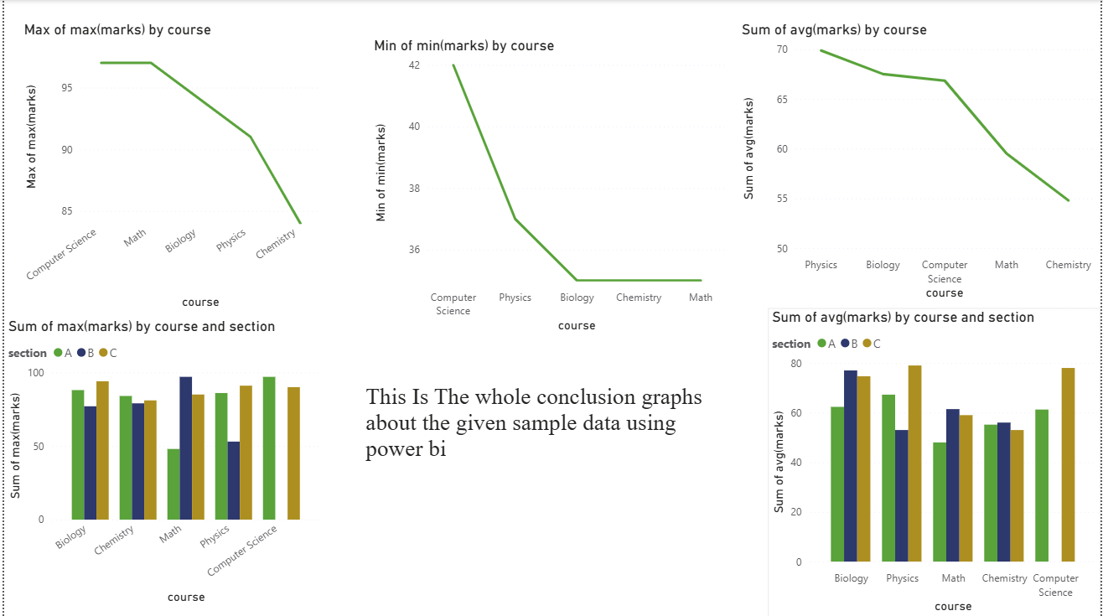

TOOLS USED:

MYSQL, POWERBI, GOOGLE (FOR DATA SETS)

PROJECT BY:

M.SRIRAJ

THANK YOU